

Accessible events guide

At Microsoft, we strive to create the most inclusive experience for all employees and customers. This guide provides Microsoft's recommendation and best practices for planning and executing an inclusive event. These recommendations are not hard and fast rules, but in our experience have been proven to create a delightful, welcoming, and inclusive experience for people with and without disabilities. For more information, visit [microsoft.com/accessibility.](http://www.microsoft.com/accessibility)

# Communications

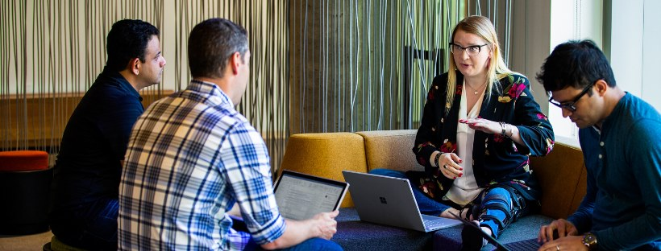

## Email Announcements

Before sending email communications, accessibility must be considered and implemented in order to create an inclusive experience for participants. You will have attendees with disabilities at your event, whether the participants identify as having a disability or not. Therefore, it is important to create an inclusive email experience from the start. These are some suggestions and best practices for creating an inclusive email experience for event attendees and followers.

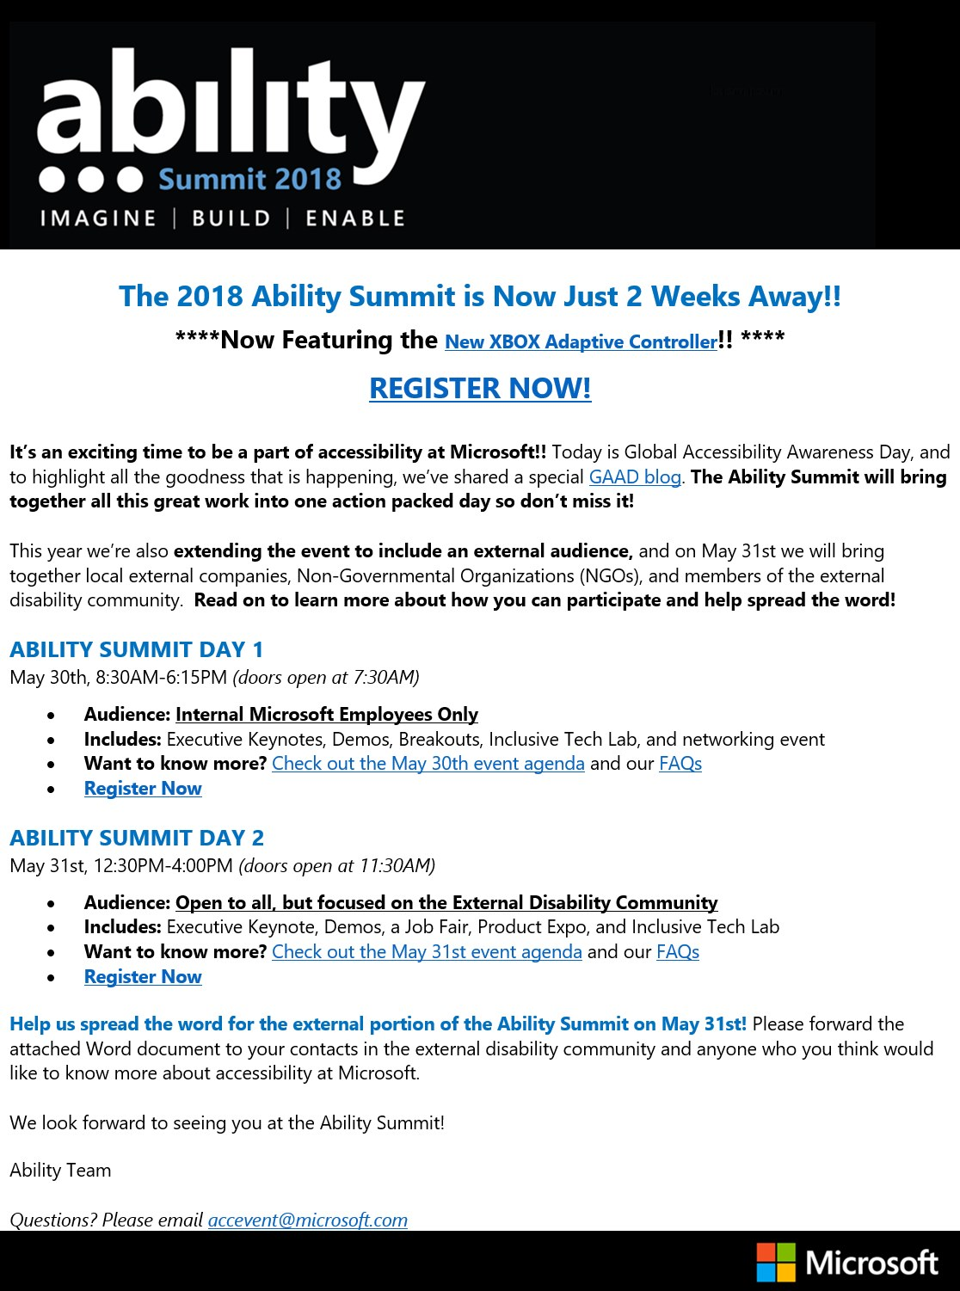

- Sample email communications prior to the Microsoft Ability Summit 2018 event

* Avoid using images ONLY as a way to communicate information about the event
  + People who are blind or have low vision may use a screen reader to read content. When images only are used, it is difficult or impossible to determine the full scope of what is provided in the email
* Add alternative text (alt text) and verify auto-generated alt text for all images in your email for people who are using a screen reader
  + Alt text provides context and meaning to the image
* When using Microsoft Outlook, use the accessibility checker to verify accessibility of your email (Review > Check Accessibility)
  + Learn more about [improving email accessibility](https://support.office.com/en-us/article/video-improve-email-accessibility-ebf3730a-18f8-4b57-81d1-730086231775?wt.mc_id=otc_accessibility_video_training&ui=en-US&rs=en-US&ad=US) in Microsoft Outlook
* Ask for accommodation requests in all email announcements prior to the event (see Accommodations and adjustments section for more information)
* Notify participants of any sensory experiences such as performances, loud music, extreme lighting, etc.
* Use inclusive language in all communications (see Inclusive language guidance section for more information). Microsoft recommends using people first language whenever possible

## Social media posts

When using social media as a way to share information about your event, remember that each social media platform may meet a different bar of accessibility. At Microsoft, we use a variety of social media platforms as a way to communicate information about events in an accessible way.

* Provide alternative text for all images
  + Alt text provides context and meaning to the image for someone using a screen reader
* Include captions for all multimedia
  + Captions ensure that people who are Deaf or Hard of Hearing can be include in viewing the video content
* Provide audio description when necessary for all multimedia
  + Audio descriptions provide auditory information about visual components of a video. For example, if there is a resource displayed on screen that is not mentioned in the dialog of the video, audio description is used to announce the resource contents for someone who is blind or has low vision.
* Use inclusive language (see Inclusive language guidance for more information)
  + Avoid outdated or offensive terms
  + Microsoft recommends using Person First Language (PFL), such as "person with a disability". However, many people with disabilities prefer Identity First Language (IDL), such as "disabled person". When in doubt, ask for clarification.
* Social media accessibility information (by platform):
  + [LinkedIn accessibility](https://www.linkedin.com/accessibility)
  + [Facebook accessibility](https://www.facebook.com/help/273947702950567)
  + [Google accessibility](https://www.google.com/accessibility/)
  + [YouTube accessibility](https://support.google.com/youtube/answer/189278?hl=en)
  + [Instagram accessibility](https://help.instagram.com/503708446705527)
  + [Twitter accessibility](https://help.twitter.com/en/using-twitter/picture-descriptions)

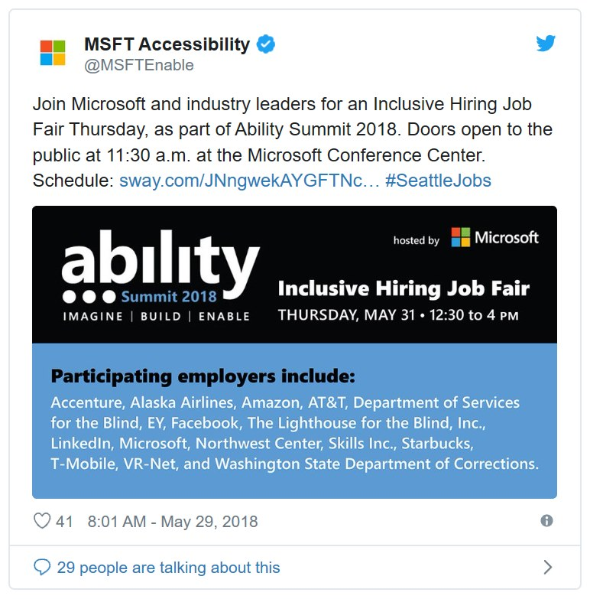

- [@MSFTEnable](https://twitter.com/MSFTEnable/status/1001478654789120001) tweet about the Ability Summit 2018 Inclusive Hiring Job Fair

## Posters and digital signage

Posters and signage are key components of any event. Attendees must be able to easily locate various spaces throughout the event space. When signage is inclusive, everyone at the event, including people with disabilities, can feel comfortable roaming the event space.

* Suggested type
  + Use a sans serif font, such as Comic Sans
    - Some people with learning disabilities prefer Comic Sans because the technical aspects tend to serve readers at a variety of levels
    - Learn more about inclusive type at [Microsoft Design](https://medium.com/microsoft-design/why-we-love-to-hate-comic-sans-bbbd9386313a)
  + Use large font size
    - For more information on large print, view the [Large Print Materials Reference Guide](https://www.loc.gov/nls/resources/general-resources-on-disabilities/large-print-materials/#top) from the National Library Service for the Blind and Print Disabled
  + Provide good color contrast
    - Ensure color contrast meets the minimum requirement for accessibility
    - Contrast ratio of 4.5:1 for small text and 3:1 for large text
    - For more information on color contrast, visit the Web Content Accessibility Guidelines 2.1 - [Color contrast resource](https://www.w3.org/TR/WCAG21/#contrast-minimum))
  + Ensure sufficient spacing between lines and paragraphs (1.0 or greater)
  + Avoid justified text
    - Justified text can cause readers to lose their place in line or can create large white spaces, causing visual distortion of text
  + Include captions for all multimedia
    - Captions ensure that people who are Deaf or Hard of Hearing can be include in viewing the video content
  + Use inclusive language (see Inclusive language guidance section for more information)
    - Avoid outdated or offensive terms such as handicapped or crippled
    - Microsoft recommends using Person First Language (PFL)

[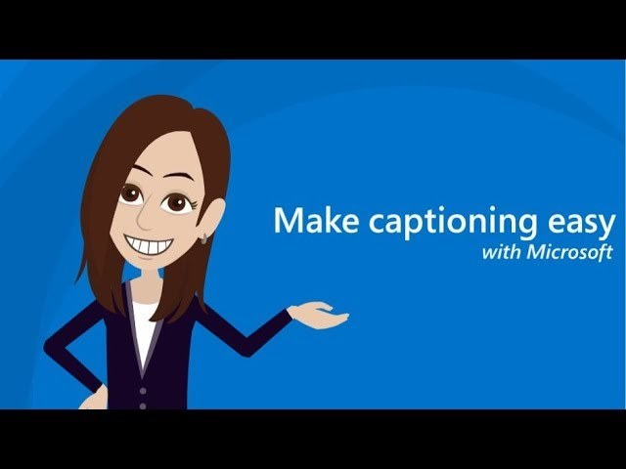](https://youtu.be/HlgarRlDY08)

- Video on suggestions for captioning multimedia and live events

## Event registration

Event registration is where people collect event materials, sign in, acquire a badge, or gather additional event information. It is important that the event registration is inclusive so that everyone at the event can fully participate in the event offerings. Here are some recommendations for creating an inclusive event registration experience:

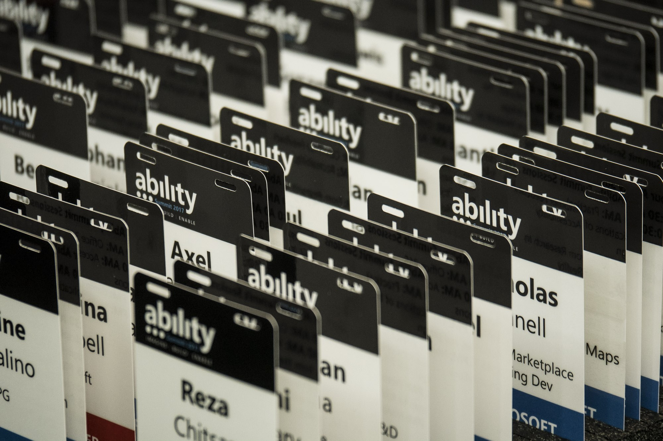

- Variety of name badges for the Ability Summit

* **Prior to the event:**
  + Provide an accessible registration form (Use [Microsoft Forms](https://forms.office.com) to create an accessible form)
  + Ask participants to identify accommodation requests such as live captioning services, documents in alternative formats (i.e. large print, Braille)
  + Ask for dietary requirements
  + Provide a field for attendees to input personal care attendant (PCA) name for badge purposes at the event
  + Provide dates and times for attendees to sign up for a walkthrough of the event space
    - Request whether accommodations will be needed for the event space walkthrough
* **At the event:**
  + Registration tables should be varied heights (low and high top) to accommodate varying mobility needs
  + Provide headphones for any digital sign-in devices
  + Ensure any digital sign-in devices (tablets, laptops, kiosks) provide assistive technology options - i.e. screen readers, text to speech, speech to text. For information on Microsoft accessibility features, review the [Accessibility Features Sway](http://www.aka.ms/accfeatures).
  + If there is audio/video at the event registration, provide captions and audio description

Embed://<iframe width="640px" height= "480px" src= "https://forms.office.com/Pages/ResponsePage.aspx?id=v4j5cvGGr0GRqy180BHbRzpFwhWGXztHnNHCf2yu5sBURTJRTFdFQzJJTFNVN0RXQzA0UTQ5TDBCVi4u&embed=true" frameborder= "0" marginwidth= "0" marginheight= "0" style= "border: none; max-width:100%; max-height:100vh" allowfullscreen webkitallowfullscreen mozallowfullscreen msallowfullscreen> </iframe>

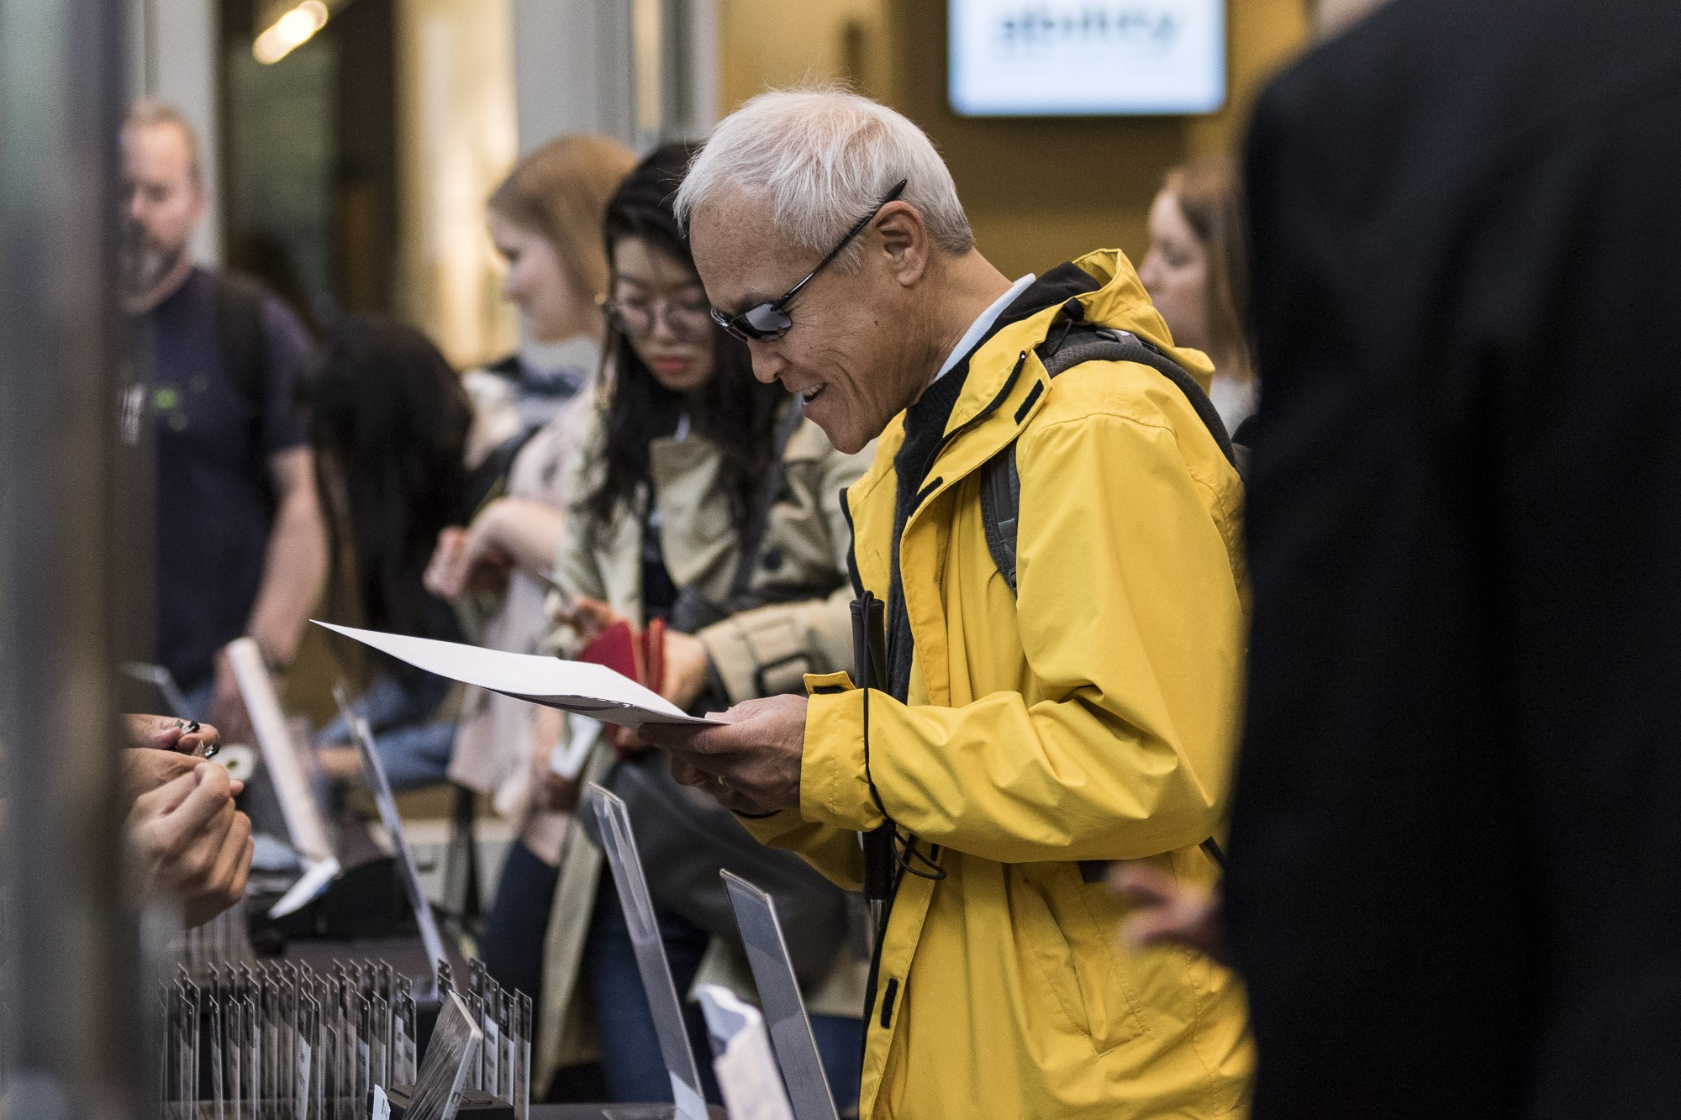

- Man reads Braille agenda at registration table.

## Event follow up

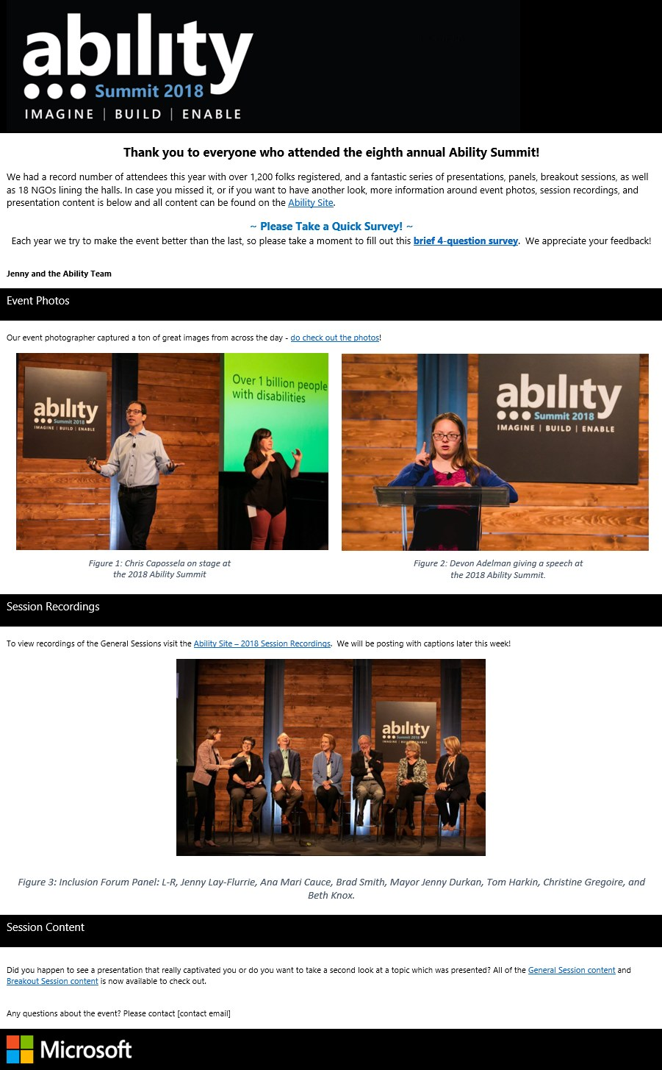

- Ability Summit 2018 follow up email including an accessible survey, links to session recordings with captions, images with alternative text, and contact information.

* Provide an [accessible survey](https://forms.office.com) to event attendees to help improve future events
* Ensure all emails are accessible
* Add alt text to all images in all communications (see Social media posts section for more information)
* Include captions for videos for distribution to attendees
* Use the Microsoft Office Accessibility Checker to verify document accessibility

# Venue

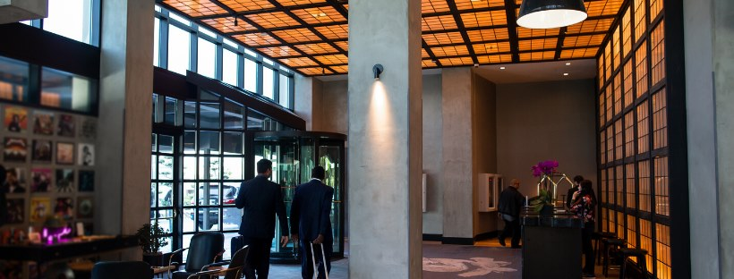

Prior to the event, ensure that your indoor and outdoor space is accessible. It is best practice to provide a walkthrough of the event space for individuals to understand the layout. Within the even registration form, solicit requests for a walkthrough of the event space (see Event registration section for more information).

## Outdoor space

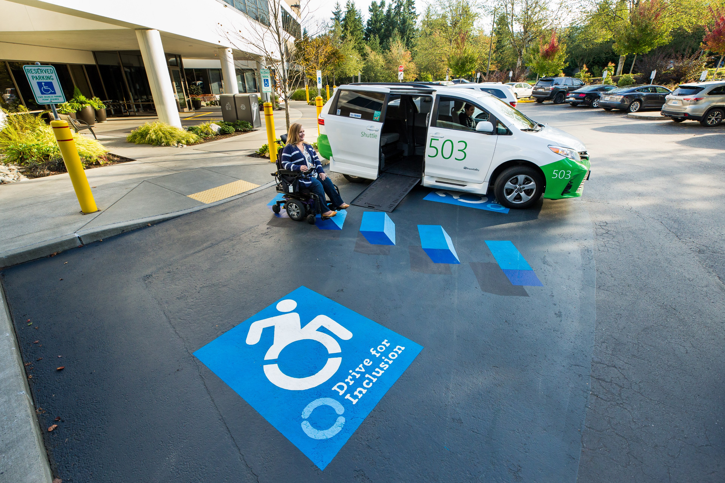

- Woman using a wheelchair approaches a wheelchair accessible shuttle van on a 3D painted disability parking stall.

* Ensure there is accessible parking with enough space on either side to allow for large vehicles and ramps
  + People who are using wheelchair accessible vehicles may require additional space next to or behind the vehicle
* Provide easily readable and identifiable signage for event location and parking
* Ensure there are ramps for entering and exiting the building. If there are not, consider booking another venue or add temporary ramps for the event
* Check for automatic doors at entrances and exits. Verify they are in working condition and they meet accessibility guidelines
  + If automatic doors are not available, provide a temporary solution such as door attendants. Best practice would be to find another location for the event that provides automatic door entrances and exits
* Eliminate rocks, sand, or uneven surfaces
  + People who are using mobility devices may not be able to use their devices on rough terrain or surfaces
* Provide mixed height (low top and high top) seating areas and tables for varying mobility needs
* Ensure ample shade for people with light sensitivities
* Provide indoor alternatives for individuals with allergies, and environmental or temperature sensitivities

## Indoor space

* When choosing an event location, consider:
  + Airflow- Fresh air accommodates people with reparatory conditions, chemical sensitivities, and allergies. Avoid venues with noisy ventilation that can be distracting for people who are hard of hearing or other disabilities
  + Acoustics - People who use hearing aids may have difficulty with ambient noise or strong echoes
  + Lighting - Natural lighting is recommended, but if that is not possible, ensure the lighting is adjustable
    - Avoid fluorescent lighting
* Provide Braille signage on amenities (bathrooms, break out rooms, etc.)
* Check for automatic doors at entrances and exits. Verify they are in working condition and they meet ADA guidelines
* Ensure access to elevators or ramps if the venue is multilevel
* Ensure [wheelchair accessible bathrooms](https://www.access-board.gov/guidelines-and-standards/buildings-and-sites/about-the-ada-standards/background/adaag) with ample clearance, grab bars, and sink height
* Provide enough space in aisles for wheelchair access, service dogs, or other assistive devices
  + For more information, view the [building guidelines and standards](https://www.access-board.gov/guidelines-and-standards/buildings-and-sites) from the United States Access Board
* Provide ramps with railings for elevated stages that meet [slope requirements](https://www.access-board.gov/guidelines-and-standards/buildings-and-sites/about-the-ada-standards/background/adaag#4.8)

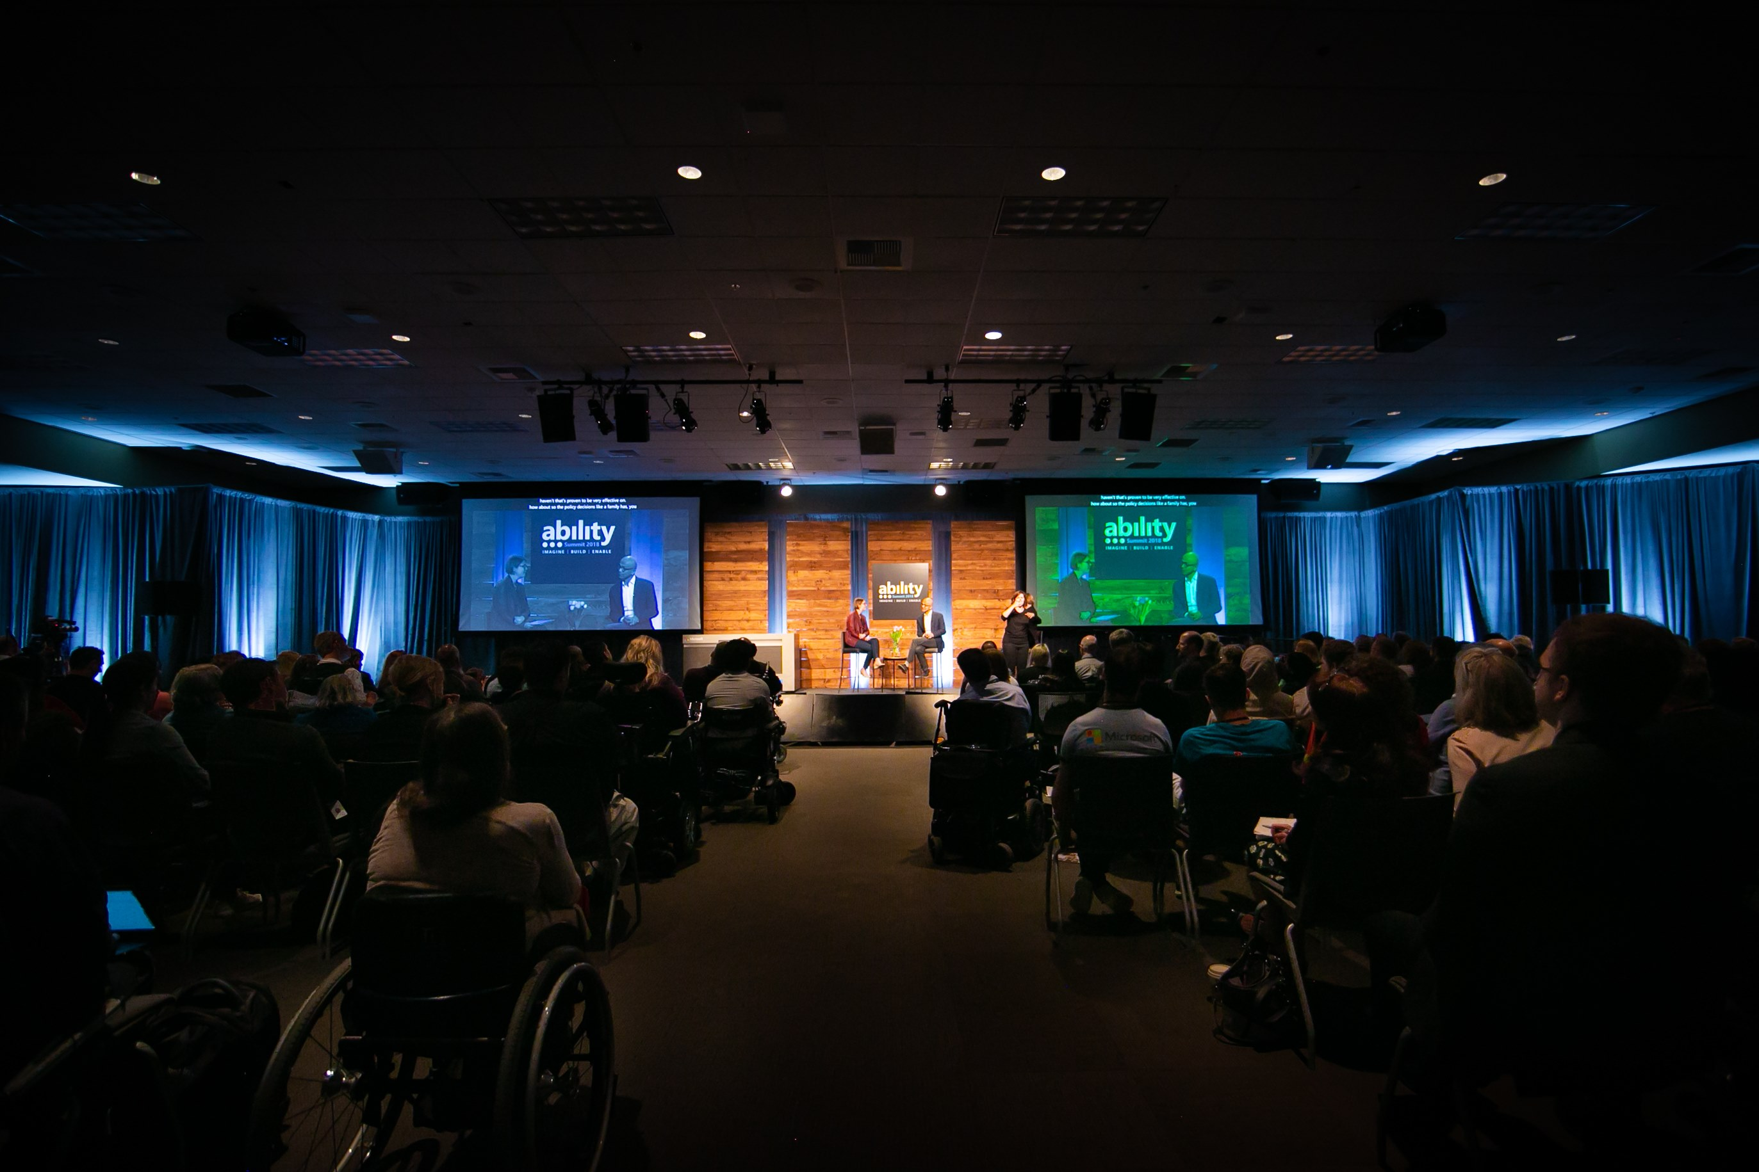

- Ability Summit 2018 mainstage with Satya Nadella, Microsoft Chief Executive Officer and Jenny Lay-Flurrie, Microsoft Chief Accessibility Officer

## Exhibit hall space

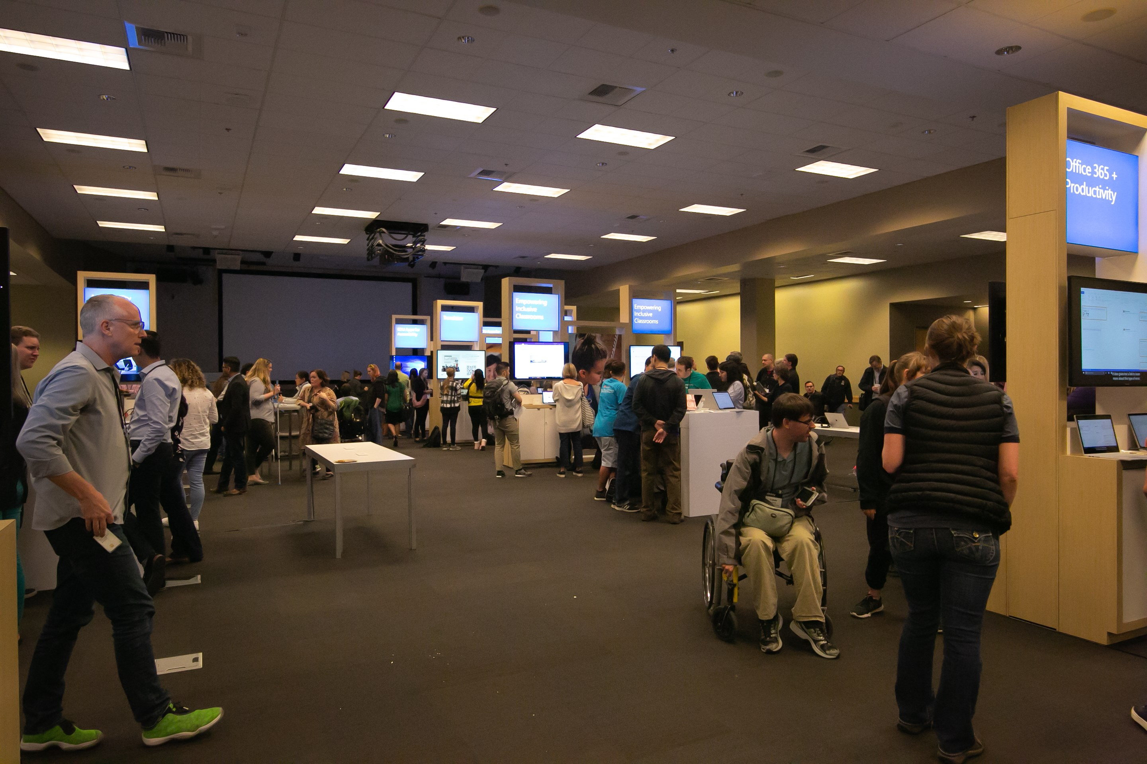

- Event exhibit hall

* Ensure ramps are available for entrances and exits of the exhibit hall
* Provide exhibit hall maps in an accessible format (digital, braille, large print)
* Provide sufficient and clear signage throughout the exhibit hall (as well as at entrances and exits)
* Ensure aisles are spaced wide enough for people to easily move through the hall

## Exhibit hall booth setup

* Provide enough space within the booth to allow for mobility devices (i.e. wheelchairs) to be able to move through freely
* Consider placing demos or lab equipment on height adjustable tables
* Provide any printed materials in alternative format
* Ensure videos have captions and audio description
  + Supply a pair of headphones
* Provide reasonable seating locations
  + Avoid beanbags, low and high top stools with no back support, or other unsupported seating
* Provide high and low top tables (with appropriate supported seating)

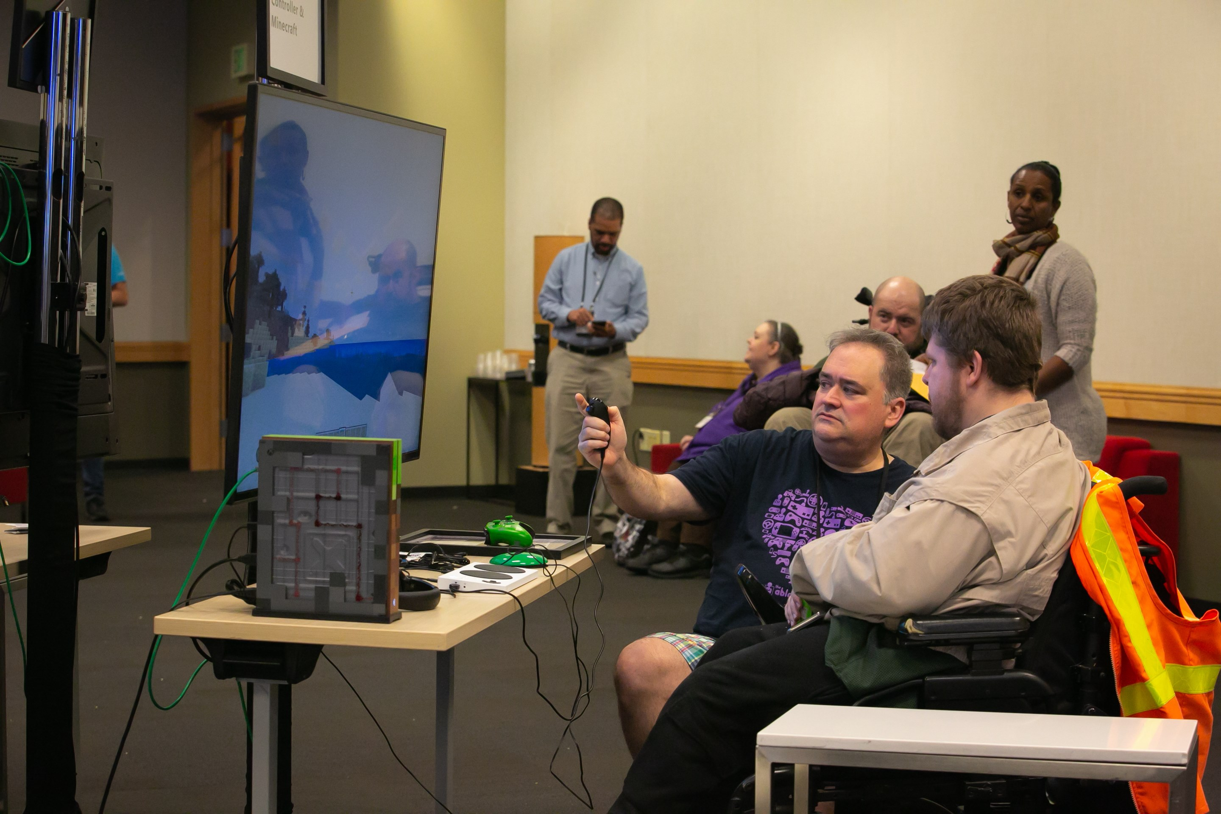

- An event attendee learns about the Xbox adaptive controller at the Ability Summit Inclusive Tech Lab

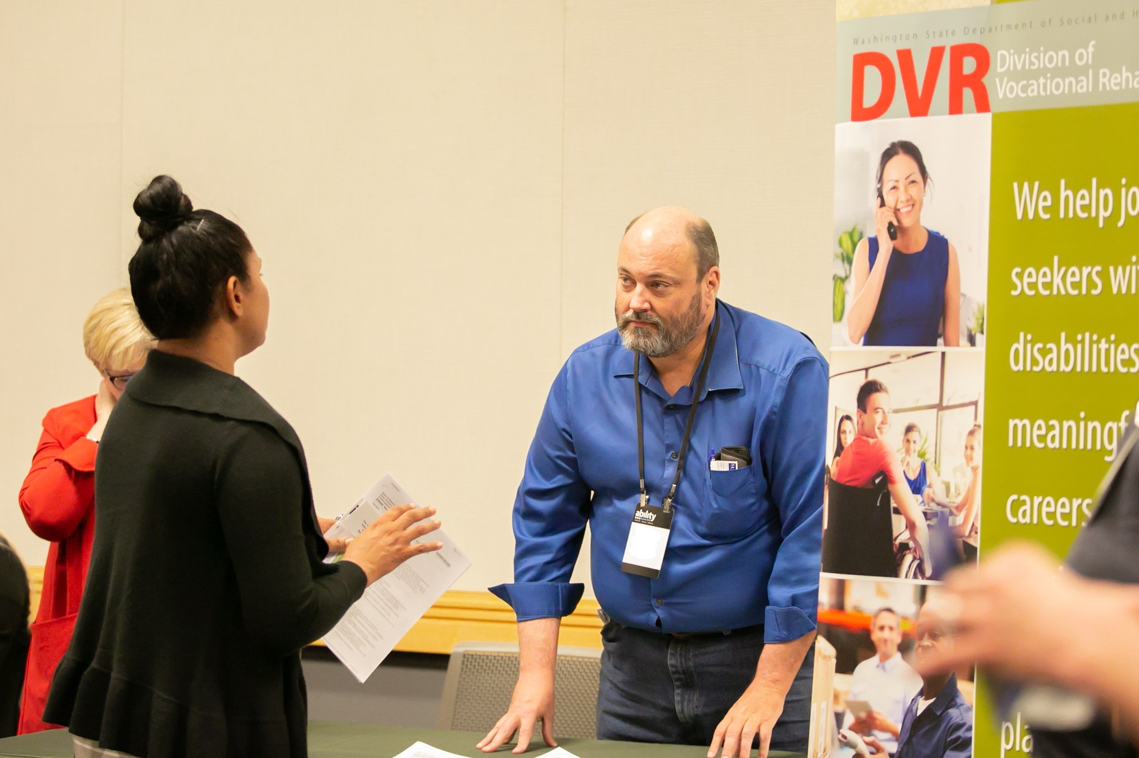

- Exhibitor from the Division of Vocational Rehabilitation at the Microsoft Ability Summit

* **Booth swag:**
  + Consider options that are inclusive of people with disabilities
    - Examples: Braille keychains, glasses cleaners, fidget spinners, carabiners, diversity within images or graphics
* **Advertising:**
  + Ensure the advertising you use for your booth is inclusive
    - Include people with and without disabilities in media advertising
    - Represent people appropriately in all advertising
  + Provide inclusive signage - Large print, Braille, sufficient contrast
  + Provide clear directions and information about your booth
    - Examples: Signage in alternative formats, descriptive directions such as "Visit booth 100 - Turn right when you enter through the exhibit hall entrance and go to the second aisle. Booth 100 is located at the end of aisle 2"

## Catering

* Provide menus ahead of time if possible. People with mental health disabilities, including people with eating disorders, may prefer to see menu options prior to the event in order to alleviate anxiety or stress related to dining
* Ask for dietary requirements at time of registration
* Consider printing large print and Braille for food and drink labels
* Food and drink labels should identify all items found in the food to ensure people with allergies or people with eating disorders are clear on the ingredients
* Use tactile signage to differentiate items such as various types of yarn for coffee, decaf and hot water. Remember to advise attendees beforehand of the tactile signage available
* Consider having servers or volunteers available during break time to assist attendees even if you are serving low maintenance meals such as boxes lunches or table serve
* Avoid calorie counts on food items. This can be triggering for someone with an eating disorder
* Buffet set up:
  + Ensure food vessels are on low tables so they are reachable by all, including wheelchair users
  + Have straws available wherever there are beverages served
  + Keep order and placement of items consistent throughout your event.  For example if you are having juice, water and soft drinks together on one table keep the order they are placed the same especially for multiday events
* Dining areas:
  + Provide mixed height (low top and high top) seating areas and tables for varying mobility needs
* Food trucks (if applicable):
  + Ensure there is an accessible path to get to the food truck
  + Provide high and low window access for ordering and receiving food
  + Provide menus in alternative formats (Braille, large print, electronic formats)

## Emergency preparedness and evacuation

All event attendees and staff must feel safe at the venue and planning for emergency evacuations must be considered when preparing for the event. Here are some emergency preparedness considerations, outlined by the [Office of Disability Employment Policy](https://www.dol.gov/odep/).

* Training for event staff
  + Disability etiquette
  + How to appropriately guide someone safely in case of an emergency
  + Evaluating an emergency
    - What constitutes an emergency?
    - Who to contact in case of an emergency?
    - Numbers to call in case of an emergency (i.e. fire department, police, poison control, etc.). Keep in mind that there may be international participants and staff at the event who may not know the local emergency contacts
    - Emergency equipment location and use
    - Evacuation policy
* Include building managers, building security, first responders, and the disability community in the event planning
* Determine when it is appropriate to use elevators in an emergency
* DO NOT exceed the maximum capacity of the venue space
* Select locations that have inclusive emergency notification systems such as lights in sync with auditory alarms that indicate an emergency
* Stairwell use
  + Prior to the event, consult with people with disabilities to determine the best coarse of action in an emergency related to stairwell movement
  + In some cases, it may not be safe to assist a person down the stairs
  + Provide evacuation chairs to use when necessary and safe
    - Identify event staff who will assist with evacuation chairs as many evacuation chairs require assisted control. Not everyone will benefit from the use of evacuation chairs, so additional evacuation plans should be implemented
  + Determine a safe place for refuge and communicate this place effectively to event attendees and staff and identify evacuation routes from the venue to the refuge location
* For more information, view the [Emergency Preparedness](https://www.dol.gov/odep/topics/EmergencyPreparedness.htm) documentation from the Office of Disability Employment Policy

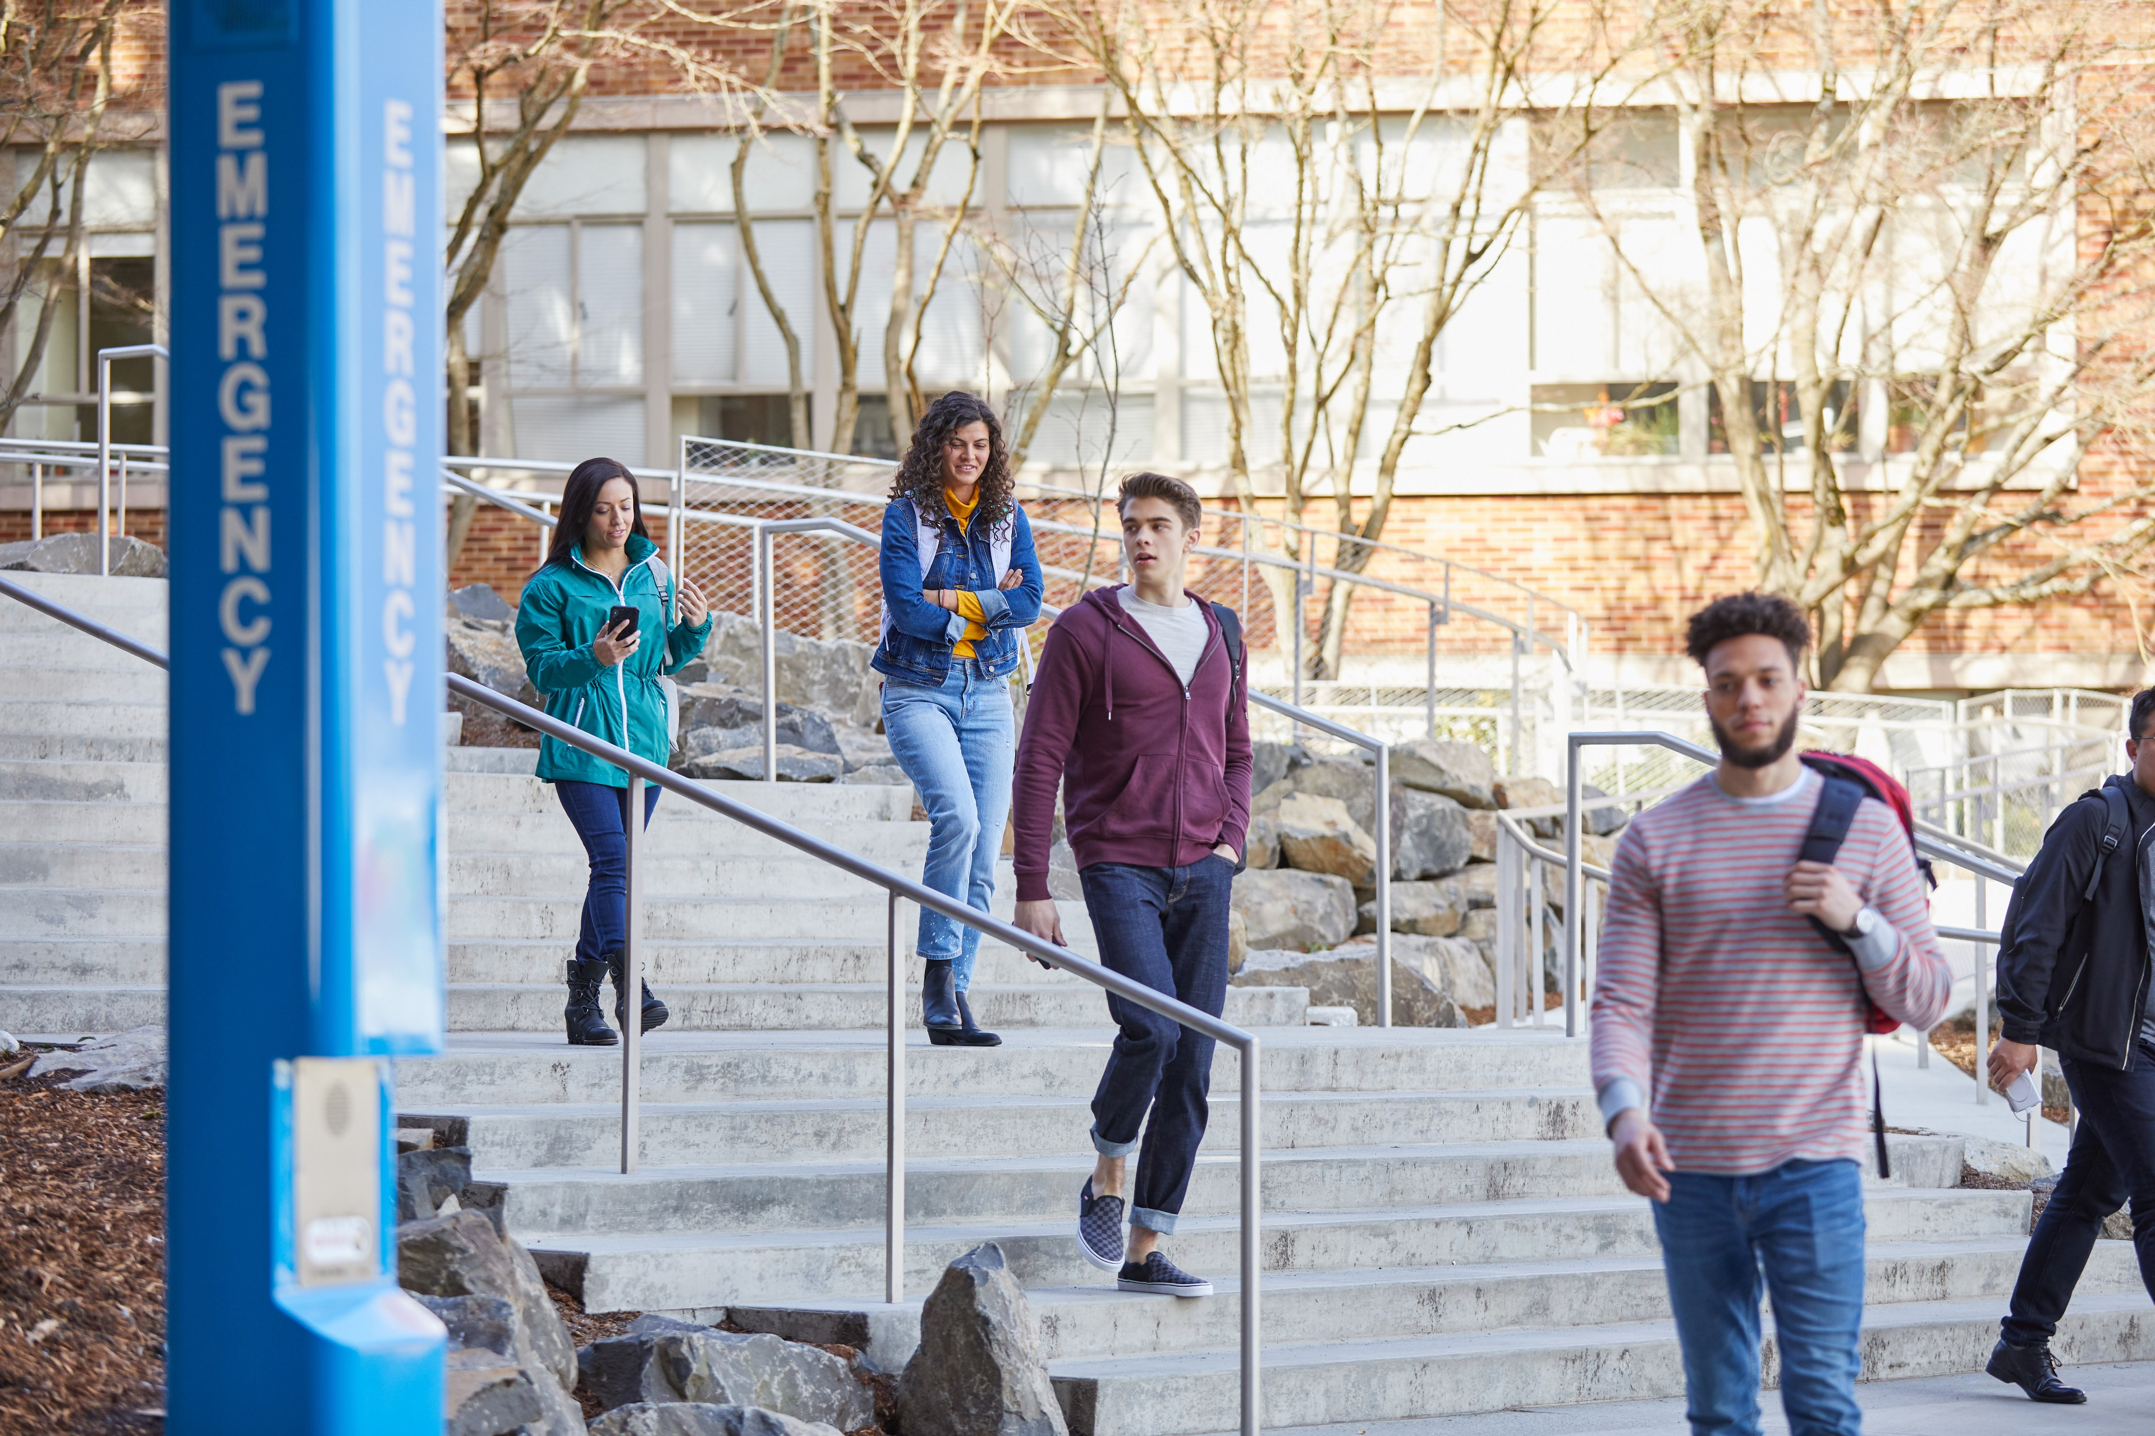

# Accommodations/Adjustments

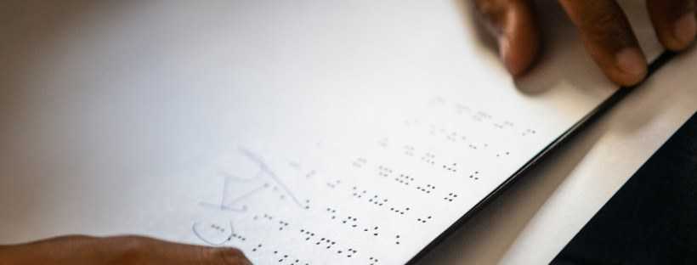

[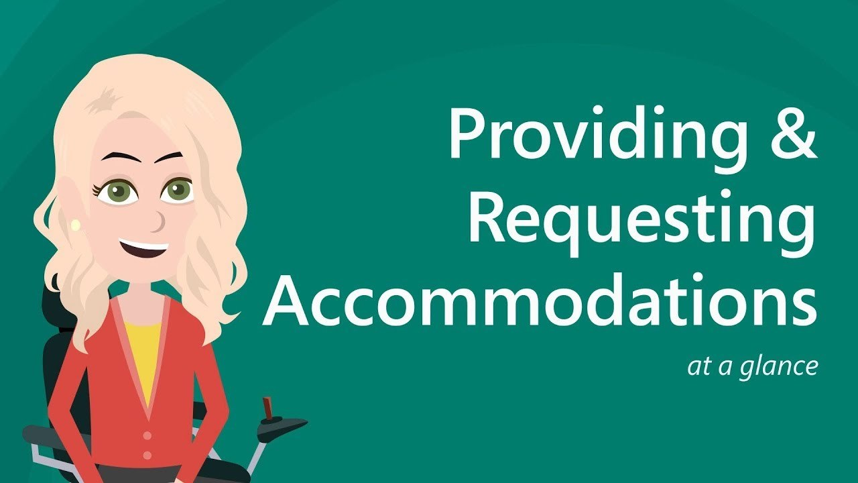](https://youtu.be/ELc-D7hTILE)

- Providing and requesting accommodations

Accommodations or adjustments are services or tools provided for individuals with disabilities to give the attendee the opportunity to fully participate in the event. Some accommodations should always be provided as a best practice, while others are more individualized and should be provided when requested by an attendee. During the registration process and throughout all communications, solicit requests for accommodations and follow up with the people who requested accommodations to ensure you are meeting the attendee's needs. Share the list of accommodations provided at the event in all event communications.

**Examples of accommodations to provide** atall events**:**

* Reserved seating (for those needing captioning or ASL Interpretation) available at the front of the room
* Reserved spaces throughout the room for people using wheelchairs, scooters, or other mobility devices
* Quiet lounge for all attendees to access throughout the event
* Live or remote captioning for general sessions
* Sign Language interpreters for general session speakers
* Stepless entry

**Examples of accommodations to provide** by request**:**

* Sign Language interpreters for breakout sessions or individual Sign Language interpreters
* Live audio description
* Braille printing
* Materials in advance
* Tours of the event space prior to the event

## Sign Language

**What is Sign Language?**

* [According to the National Association of the Deaf](https://www.nad.org/resources/american-sign-language/what-is-american-sign-language/), "Sign language is not a universal language — each country has its own sign language, and regions have dialects, much like the many languages spoken all over the world."
* Sign Language incorporates the shape, placement, and movement of the hands, facial expressions, and body positioning and movements to convey information.

**What is American Sign Language?**

* American Sign Language is typically used among people in the United States and Canada.

**What is International Sign?**

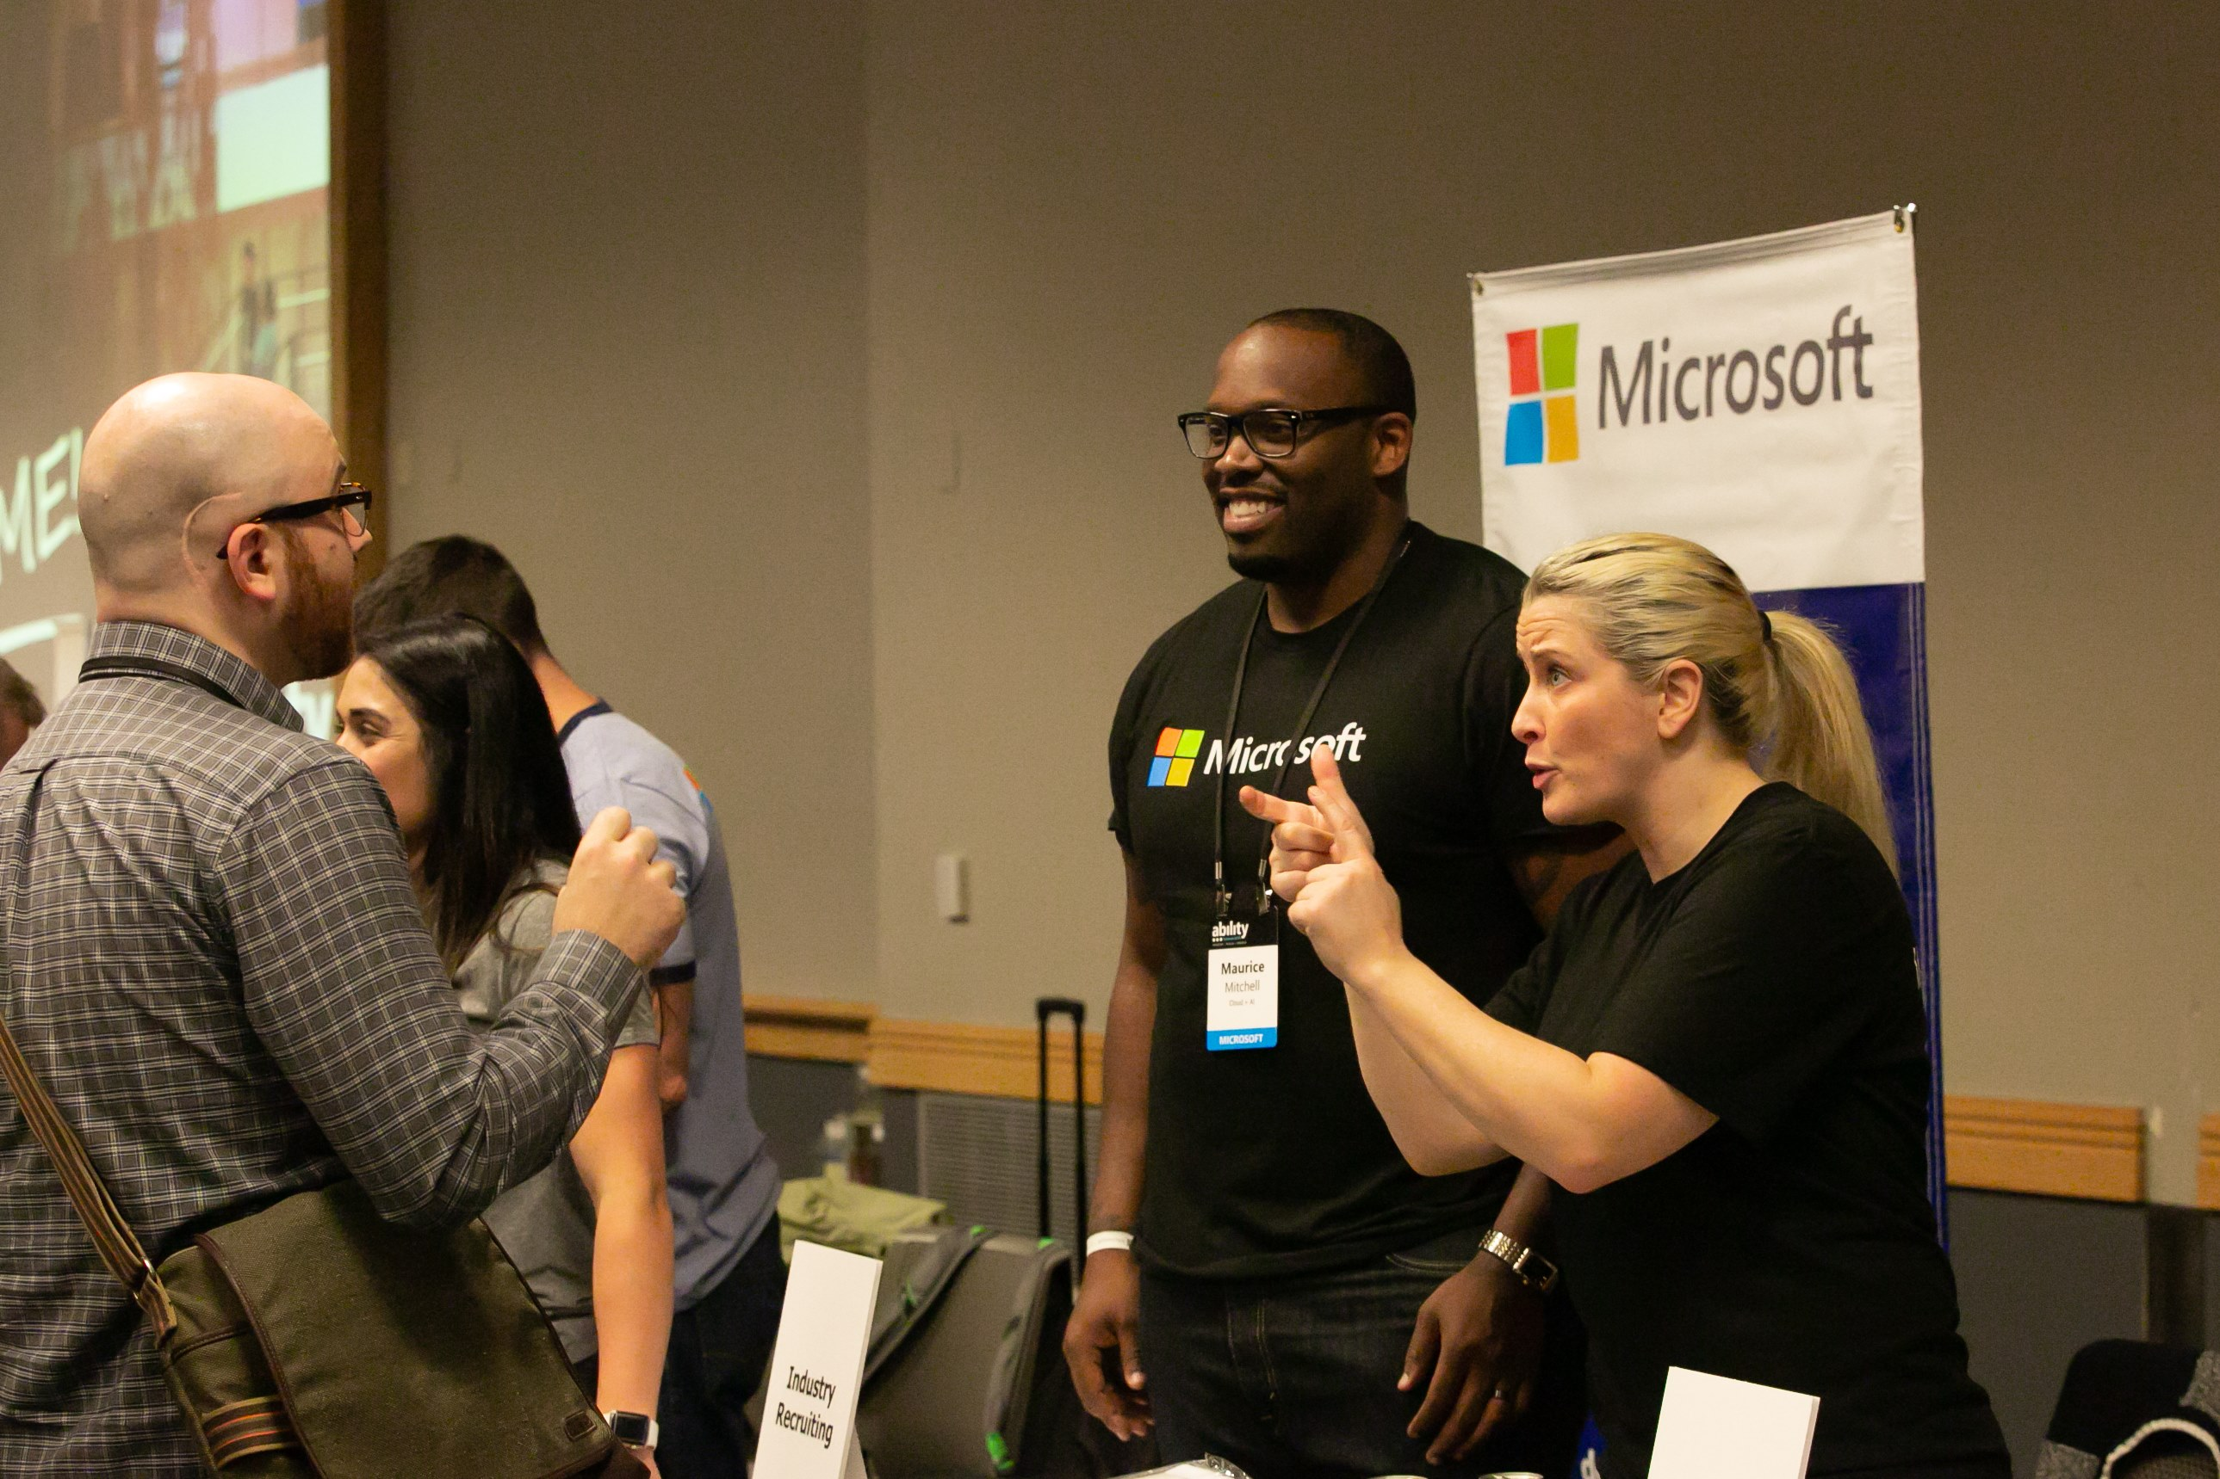

- A person who is deaf converses with a Microsoft employee at the Ability Summit Job Fair

* Provide a well list space to ensure Sign Language communicators can easily see interpreters
* Provide material to the Sign Language interpreters prior to the event
  + If the presenter is speaking on a technical subject, ensure the Sign Language interpreters are technical interpreters or are familiar with the terminology and topic

## Captions and Communication Access Real-time Translation (CART services)

Captions are on-screen text which display both speech and non-speech elements, such as music and sound effects, synchronized with the video playback. Captions can be useful for people who are Deaf or Hard of Hearing, as well as people who speak different languages. Closed Captions allow for the viewer to toggle the captions on or off via the online video player. Open Captions are always on or ‘burned’ onto the video and cannot be turned off by the viewer.  When presenting a video to an audience, open captions should be used. Communication access real-time translation or CART services is live captioning for speakers and other non-speech auditory elements such as "laughter" or "applause". Captioners can be in the event space or remote, and the captioning is presented in real time.

[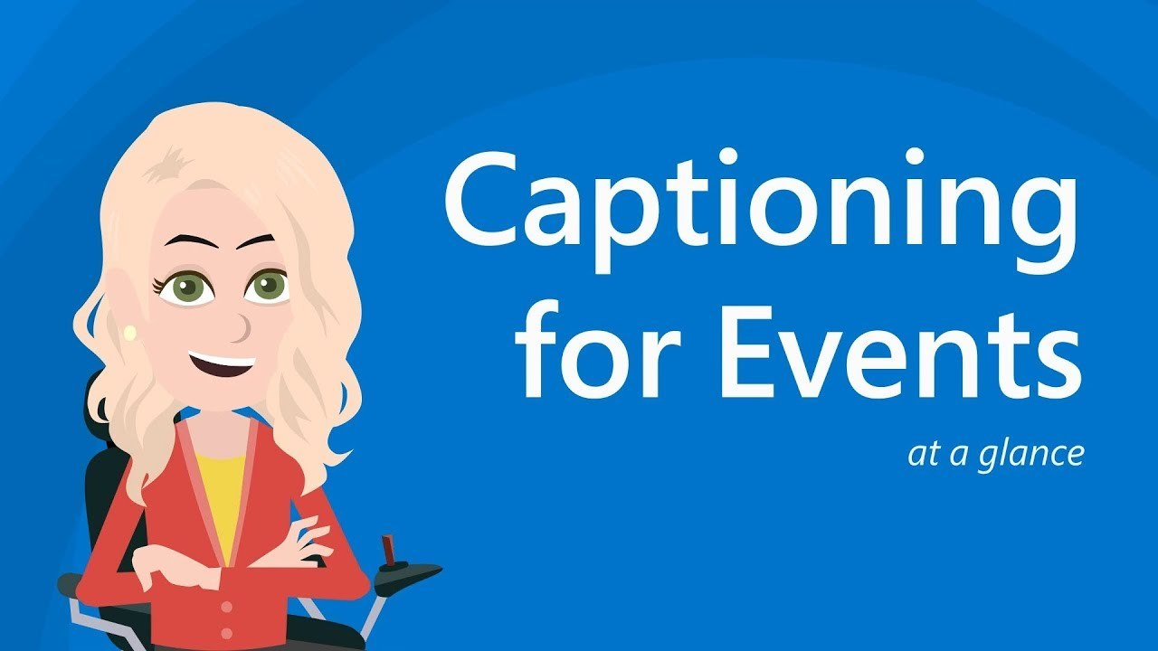](https://youtu.be/1ZfGNxlR4rg)

- Captioning for events

* **Captioning:**
  + Captions must have sufficient color contrast and should use a sans-serif font
  + Move any screen obstructions to avoid covering or blocking captions
  + Provide presentation material to live captioners prior to the event
* **CART Services:**
  + Choose a reputable CART vendor
  + Provide reserved space at the front of the room for the CART writer
  + Provide presentation material to CART writers prior to the event
  + Ensure live captioning is presented on a large screen with large enough font and has good color contrast
* For more information on captioning and CART services, view the [Captioning and CART resource](https://www.hearingloss.org/hearing-help/technology/cartcaptioning/) from the Hearing Loss Association of America

## Live audio description

Audio description is narration of visual components of a video or performance for a person who is blind or has low vision. While audio description should be provided for multimedia (when necessary), live audio description can be provided as an accommodation/adjustment for someone that requests it. Live audio description is real time narration of a live performance, event, demonstration, or experience.

* Choose an experienced live audio description vendor
* Provide material to live audio describers prior to the event
* For more information, visit the [American Council of the Blind, The Audio Description Project](http://www.acb.org/adp/)

## Sensory experiences

Sensory experiences are activities, objects, or spaces at the event that provide a calm environment. Events can be overwhelming. Sensory experiences can help to lower anxiety and stress levels. Some examples of sensory experiences include quiet spaces, cuddle corners, silent discos, and sensory objects such as building blocks or slime.

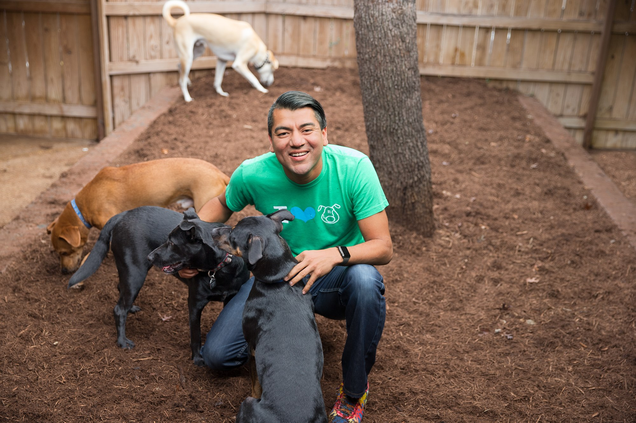

- A cuddle corner at an outdoor event

* **Quiet spaces**
  + Ensure the space is close to the main event activities
  + Provide signage for quiet space locations
  + Provide clear rules on what can be brought into the quiet space
    - It is best practice to remove or prohibit any use of technology in the quiet space but in some cases, person headphones are acceptable. Ensure the rules state that music or audio devices (with headphones only) must be low enough so that people in the room cannot hear through another person's device.
  + Use natural lighting
    - Avoid fluorescent lighting
  + Provide comfortable and reasonable seating areas (low and high top)
    - Avoid office furniture
    - Avoid bean bags or stools
* **Cuddle corners:** Cuddle corners are areas at the event where people can pet, play, or observe animals such as rabbits, cats, dogs, horses, and more. They provide an opportunity for event participants to relieve stress and focus on something unrelated to the hustle and bustle of the event. Animals can be a great tool for providing comfort to people when the environment is stressful or overwhelming
  + If providing cuddle corners, ensure that clear signage is available to allow people with allergies to keep a safe distance
  + See how Microsoft is providing [stress reducing environments](https://www.seattletimes.com/business/microsoft/software-developers-take-cuddle-break-with-farm-animals-at-microsoft-build-conference/) at large conferences

## Personal Assistants

Some people with disabilities utilize assistants, such as Personal Care Attendants (PCA) and Sighted Guides. PCAs are professionals that can provide medical care to the person with a disability. Sighted guides are support professionals hired to guide people who are blind or have low vision to various locations at the event.

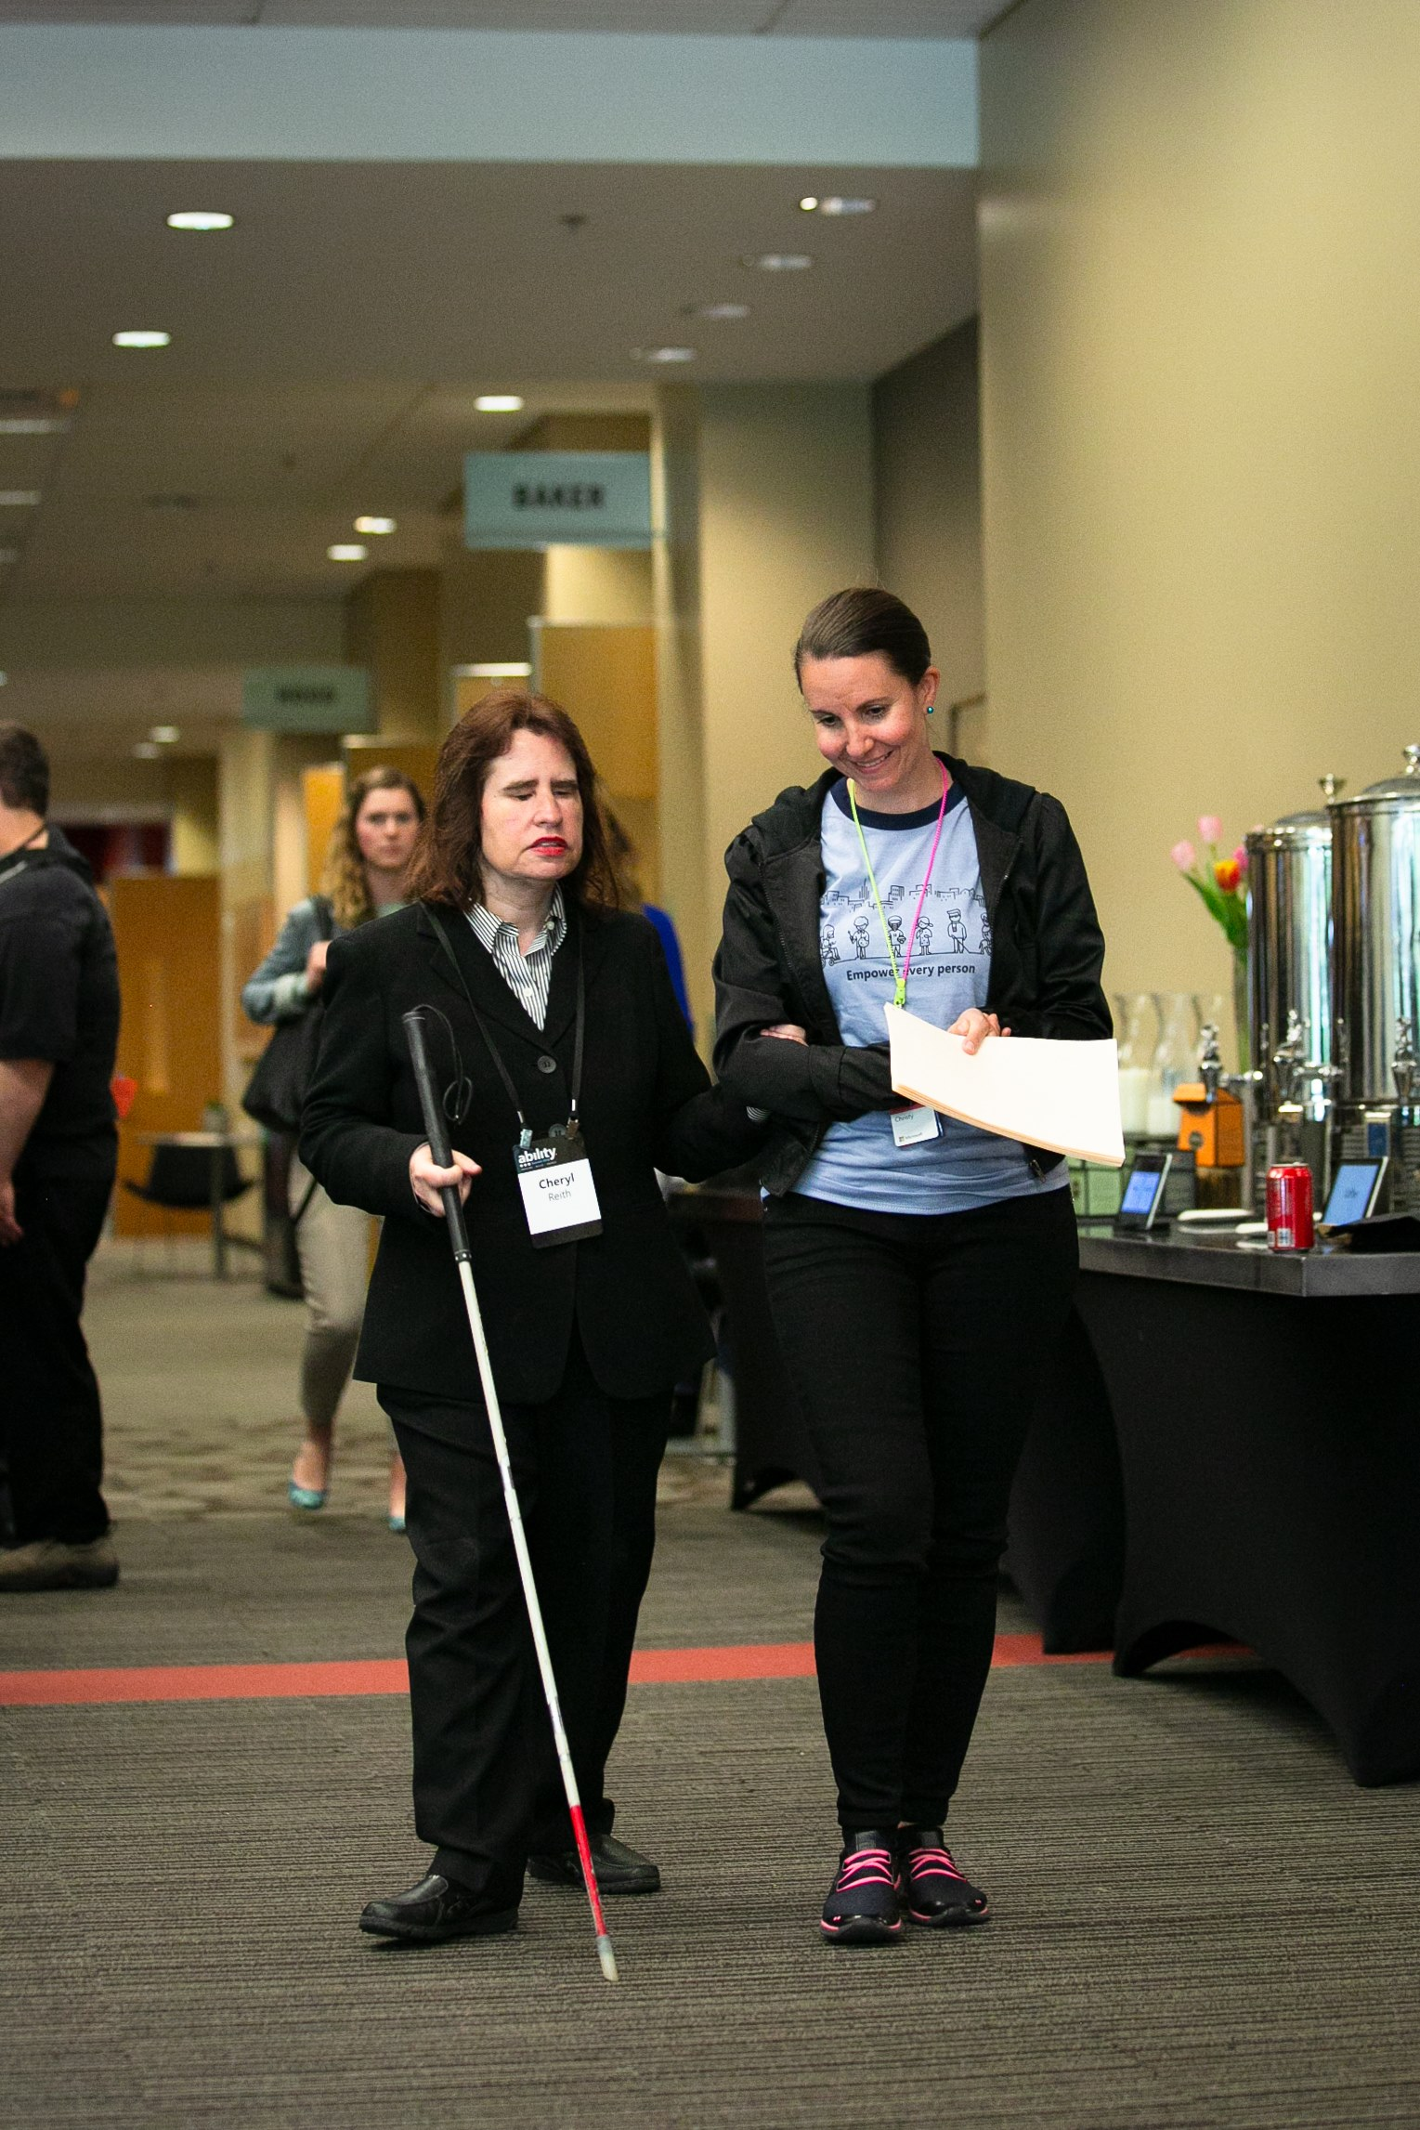

- Event volunteer guiding a person who is blind

* During registration, ask attendees to register their assistants by name. Event staff will be able to create name badges in advance
* Remember to take assistants into account for catering and space considerations

## Alternative formats

Event materials such as menus, maps, and agendas, should be made available in electronic formats in advance of the event. Attendees may specifically request additional alternative formats, such as Braille and Large Print. Engage with your Braille supplier early in order to fulfill Braille requests in time for your big day.

* Braille printing
* Consider printing large print material or upon request
  + Learn more about [large print guidelines](http://www.acb.org/large-print-guidelines)
* Provide [tactile maps](https://lighthouse-sf.org/braille-translation/braille-tactile-maps/) for people who are blind or have low vision

# Disability etiquette

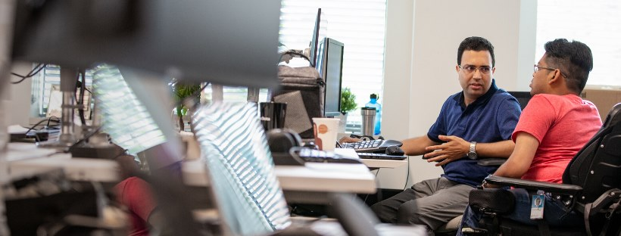

## Inclusive language guidance

* Avoid outdated terminology such as *handicapped or crippled
* Examples of Person First Language:
  + Person who uses a wheelchair
  + Engineer with Post Traumatic Stress Disorder
  + Executive with Dyslexia
  + Person who is Hard of Hearing
  + Man who is blind
* Examples of Identity First Language:
  + Autistic person
  + Dyslexic person
  + Disabled person
  + Wheelchair-user
  + Depressed person

*While some people with disabilities prefer to use Person First Language, others may prefer to use Identity First Language. For example, in the Autism community, using the term "Autistic person" rather than "person with Autism" is typically the preferred method of identification. If someone uses the term "handicapped" to describe themselves, do not correct them. People can refer to themselves and use terminology to describe themselves in any way they prefer. Person First Language is Microsoft's recommendation when presenting at an event or communicating about a person with a disability, unless otherwise noted.

## Interacting with people with disabilities

* Ask first, then assist
  + Do not assume someone needs your help. Offer assistance before guiding.
  + Do not pull, touch, or push someone's assistive device such as a wheelchair or cane. This can be dangerous and could cause injury.
* When guiding a person who is blind, ask if they would like to take your elbow. Extend your elbow and tell the person where you are standing by using directional terms ("I'm offering an elbow to assist on your right")
* When trying to get someone's attention, tap lightly on the person's shoulder
* Use directional terms and specific points of reference (avoid using gestures or vague terms when describing a location at the event)
  + Example: Say "Walk straight about 10 feet, turn right, and it will be the second door on your left".
  + Offer to guide or lead the person to their desired destination

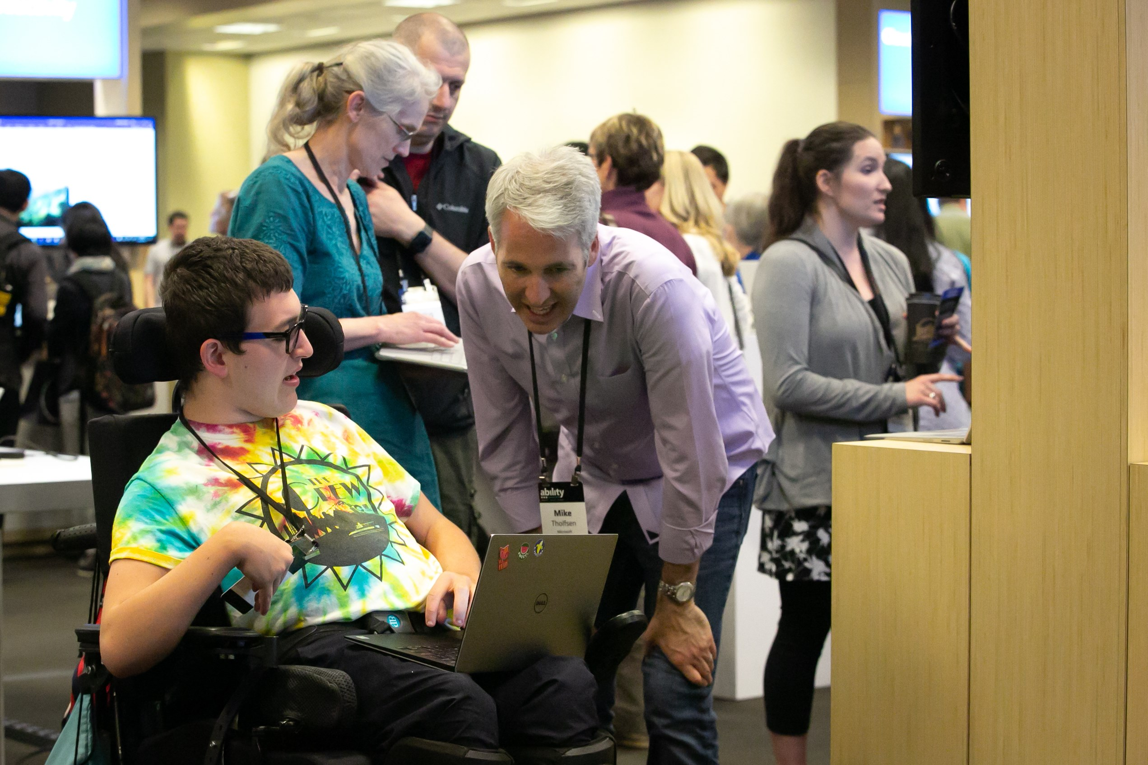

- Microsoft employee speaking with an event attendee at the Microsoft Ability Summit

## Portrayal of people with disabilities in media

Embed://<div style="max-width:854px"><div style="position:relative;height:0;padding-bottom:56.25%"><iframe src="https://embed.ted.com/talks/stella_young_i_m_not_your_inspiration_thank_you_very_much" width="854" height="480" style="position:absolute;left:0;top:0;width:100%;height:100%" frameborder="0" scrolling="no" allowfullscreen></iframe></div></div>

* Represent people with disabilities appropriately
* Do not objectify people with disabilities
* When telling a story about a person with a disability:
  + The person with the disability is the hero, not the technology or tool you are showing (the technology is not meant to "save" or "fix" the person with a disability)
  + Avoid using inspirational music that is intended to make you "feel bad" for the person with the disability
  + Ensure the person with the disability is talking about themselves rather than others talking for or about them
* Watch Stella Young's TED Talk, "[I'm not Your Inspiration, Thank You Very Much](https://www.ted.com/talks/stella_young_i_m_not_your_inspiration_thank_you_very_much?utm_campaign=tedspread&utm_medium=referral&utm_source=tedcomshare)" to learn more about how to avoid objectification of people with disabilities

# Event staff and speakers

## Training for event staff

It is best practice to provide training for inclusive event staff (including volunteers and presenters) prior to the event to allow for enough time to ask questions, retain information, and practice presenting in an inclusive way.

[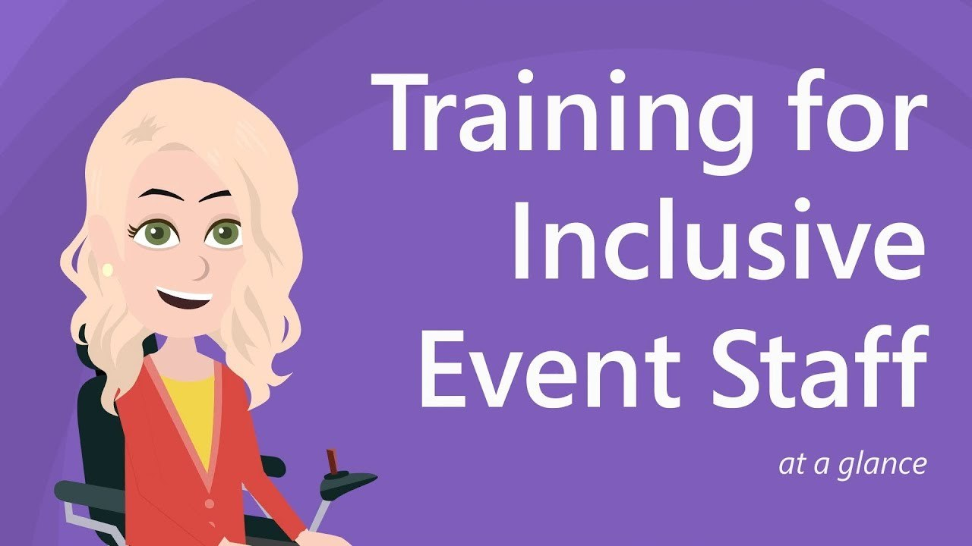](https://youtu.be/QPEwlj3jhGc)

- Training for inclusive event staff

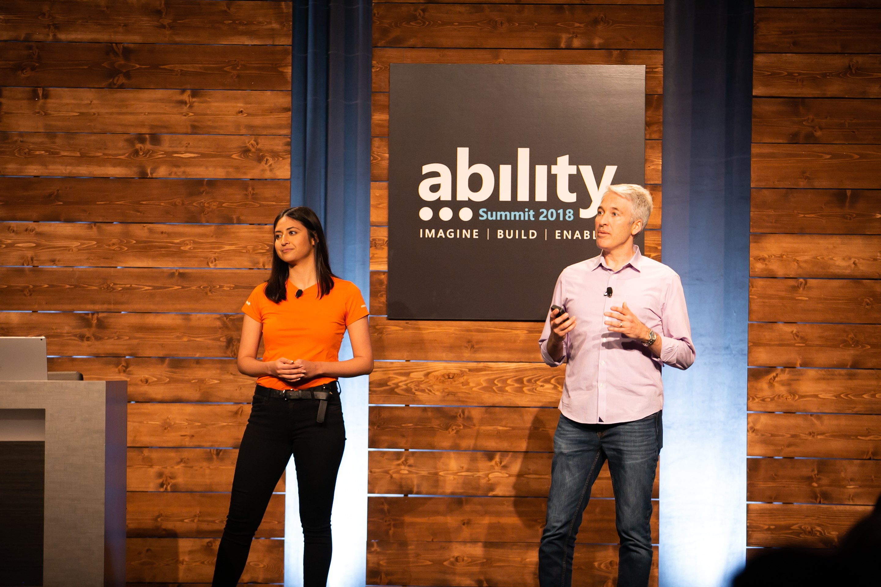

- Mike Tholfson presents at the Microsoft Ability Summit 2018

* **Event staff and volunteer training:**
  + Using appropriate language (see Inclusive language guidance **section** for more information)
  + How to best approach or grab the attention of an attendee with a disability
  + Giving directions
  + Being a sighted guide
  + Guiding or leading participants to a location
* **Presenter training:**
  + Using appropriate language (see Inclusive language guidance section for more information)
  + Presenting in an inclusive way (see Speaker recommendations section for more information)
  + Microsoft PowerPoint accessibility (see PowerPoint slides section for more information)

## Speaker recommendations

* Always use a microphone
  + Even if you believe you have a loud voice, the microphone benefits attendees with varying levels of hearing.
  + Microphones help to create more accurate captions and transcripts
  + Repeat questions from the audience into the microphone.
* Speak clearly, face forward and avoid covering your mouth to benefit people that read lips.
* Avoid sidebar conversations (conversations happening during a presentation or outside of the conversation during an event)
* Avoid acronyms and colloquialisms. Don't go swimming in alphabet soup. Remember your audience may not know your organization's acronyms. Practice your presentation in advance to catch yourself using acronyms. (i.e. LOL)
* Identify yourself each time you speak to provide context for someone who is blind or has low vision
* Clearly describe any images, charts, tables, etc. that are important for understanding the presentation content

[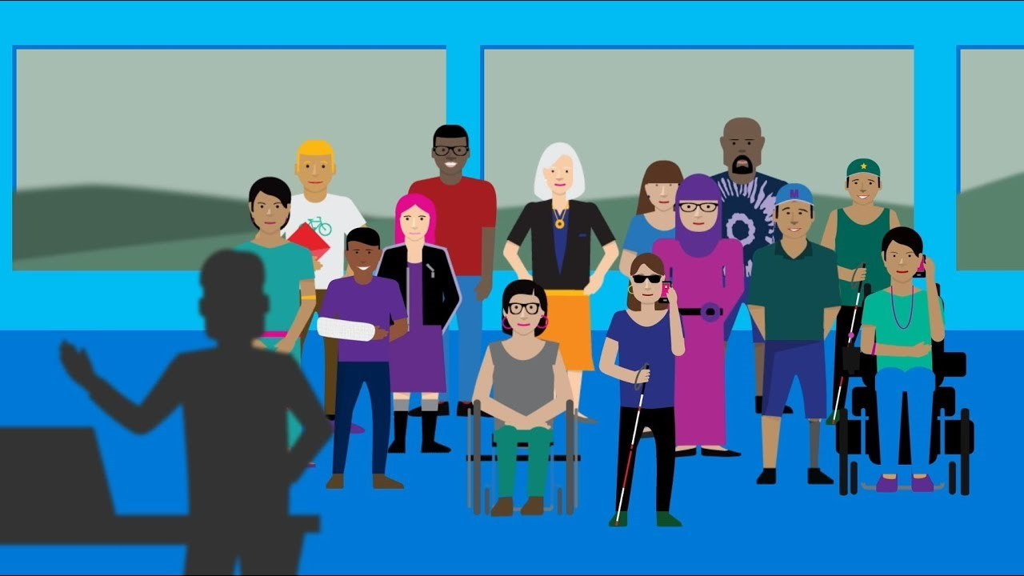](https://youtu.be/4uiBYqW4mj8)

- Inclusive presentation skills

## PowerPoint slides

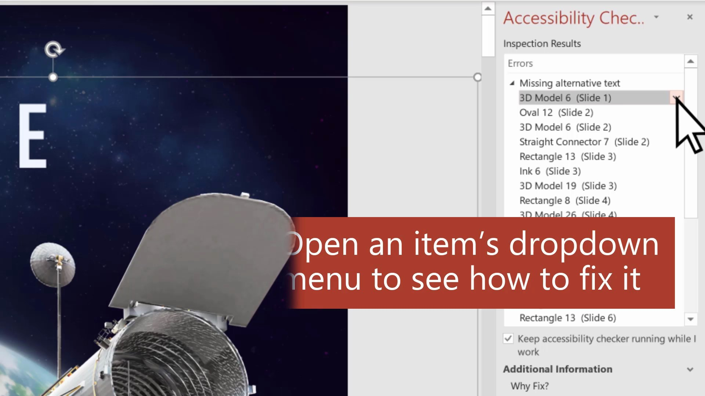

<https://sway.office.com/Uk6btnkIIONW6ZmI#content=SaA5eNXYtWL7uc>

- How to use the Accessibility Checker in PowerPoint

* Use the accessibility checker in the review tab (Review tab > Check Accessibility)
* Add alt text to images (right click or use the applications key > select Edit Alt Text > Add a descriptive alt text or mark as decorative depending on the image type)
* Set reading order in the Selection pane (Items displayed in the selection pane from bottom to top will identify the reading order of a slide)
* Add captions to videos (upload video > Playback tab > select Insert Captions)
* Add slide titles (View tab > select Outline View > enter title text or select open the Accessibility Checker > Find the error "Missing Slide Title" > Expand the drop down menu in the accessibility checker for that error > Make a selection based on your content)
* Check for sufficient color contrast
* Use a sans-serif font
* Use a simple layout whenever possible
* Avoid adding too much text on a slide

## Word documents

* Use the accessibility checker in the review tab (Review tab > Check Accessibility)
* Use a sans-serif font
* Check for sufficient color contrast
* Add headings for document structure (Home tab > Styles > Select the desired heading style/order based on the structure of the document)
* For more information on creating accessible Microsoft Word documents, visit [aka.ms/officeaccessibility](http://aka.ms/officeaccessibility)

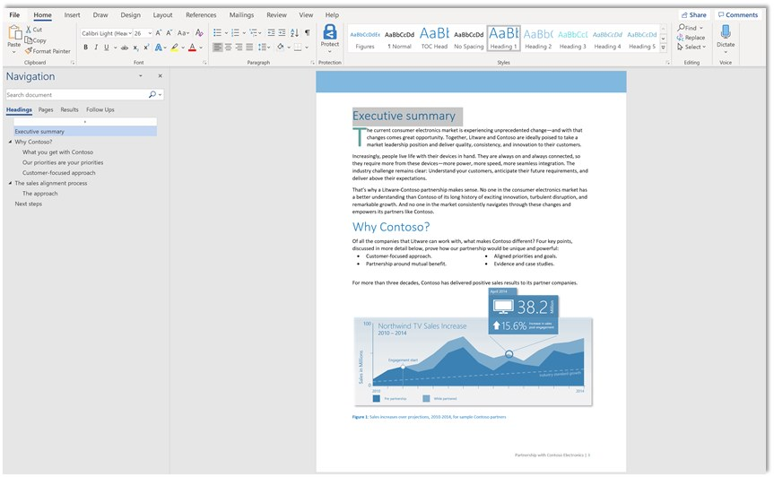

- Microsoft Word document with headings set using the set Styles in the Home Tab

## Printed documents

* Use a sans serif font, such as Comic Sans
  + Some people with learning disabilities prefer Comic Sans because the technical aspects tend to serve readers at a variety of levels
  + Learn more about inclusive type at [Microsoft Design](https://medium.com/microsoft-design/why-we-love-to-hate-comic-sans-bbbd9386313a)
* Provide sufficient color contrast
  + Check the foreground color against the background color to verify sufficient contrast
  + To test for sufficient color contrast, use the [WebAIM Contrast Checker](https://webaim.org/resources/contrastchecker/)
* Provide printed information in an electronic format
* Consider printing in alternative formats (see the Alternative formats section for more information)

## Videos

* Include captions for all multimedia
  + Captions ensure that people who are Deaf or Hard of Hearing can be include in viewing the video content
* Provide audio description when necessary for all multimedia
  + Audio descriptions provide auditory information about visual components of a video. For example, if there is a resource displayed on screen that is not mentioned in the dialog of the video, audio description is used to announce the resource contents for someone who is blind or has low vision.
* Use appropriate language and represent people with disabilities appropriately (see the Portrayal of people with disabilities in media section for more information)

# Other considerations

Here are some additional considerations to include at your event to provide the most accessible experience possible.

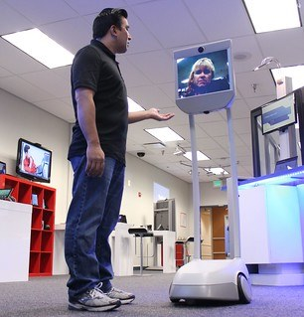

- Person speaking to a remote attendee on the Beam robot

* Water bowls for service animals
* Designated relief area for service animals (owners are responsible for cleanup)
* Fidget or sensory bins/toys on tables
* For parties during or after the event
  + Ensure any location you choose for parties or gatherings follows the same recommendations of inclusive guide
  + Silent discos
  + Consider events that are not focused on food and/or drinks. Dining events can be stressful for people with allergies or people with eating disorders
* Assisted listening devices - ex. FM systems
  + Learn more about assisted listening systems and devices from the [National Association for the Deaf (NAD)](https://www.nad.org/resources/technology/assistive-listening/assistive-listening-systems-and-devices/)
* Robots for remote attendees
  + Learn about the [Beam Robot](http://bepresent.in/) for remote access

# Inclusive events checklist

Download the [accessible events checklist](https://microsoft.sharepoint.com/:w:/t/EvangelismTrainingandReadiness/EVBJY7bkghtBrf8-y7nLo34Bh_z9eANoL8-0Ahiz7kOt3w?e=JUHicT) to help plan and execute your next accessible and inclusive event.

# Additional resources

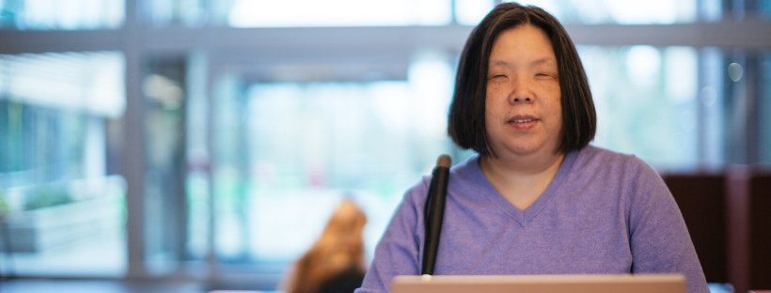

[Microsoft accessibility home page](https://www.microsoft.com/accessibility)
[Office accessibility](http://aka.ms/officeaccessibility)
[Windows accessibility](https://support.microsoft.com/en-us/hub/4339839/windows-accessibility-help?os=windows-10)
[Enterprise Disability Answer Desk (eDAD)](https://support.microsoft.com/en-us/accessibility/enterprise-answer-desk)
[Disability Answer Desk (DAD)](https://www.microsoft.com/en-us/Accessibility/disability-answer-desk)
[Microsoft accessibility training materials](https://www.youtube.com/msftenable)
[The Audio Description Project](http://www.acb.org/adp/) (external resource)
[Rooted in Rights](https://rootedinrights.org/) (external resource)
[National Association for the Deaf (NAD)](https://www.nad.org/resources/technology/assistive-listening/assistive-listening-systems-and-devices/) (external resource)